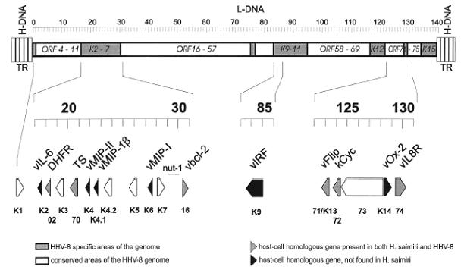

HHV-8 specific areas of the genome
host-cell homologous gene present in both HVS and HHV-8
host-cell homologous gene, not present in HVS
non host-cell homologous gene
conserved areas of the HHV-8 genome

Figure 1.2. Schematic diagram of the structure of the HHV-8 genome (Neipel and Fleckenstein, 1999). A long unique coding region of 140.5 kb with low-GC content (53.3% G + C, L-DNA) is flanked by two terminal repeats of 801 bp which have a high-GC content (84.5% G + C, H-DNA). There are at least 89 ORFs within the L-DNA region. Many of these regions, represented by the open boxes in the top part of the figure, are homologs of genes found in other herpes viruses. The grey boxes represent non-conserved regions, most of which are involved in HHV-8 pathogenesis. In the enlarged insert at the bottom of the figure, the black arrows indicate homologous cellular genes not found in HVS, light grey arrows indicating genes homologous to both cellular and HVS genes and open arrows indicating genes without known homology to cellular genes.
vIL-6 (viral interleukin-6); DHFR (dihydrofolate reductase); TS (thymidilate synthase); vMIP-I/II (viral macrophage inflammatory protein-I/II); vMIP-1 β (viral macrophage inflammatory protein-1 β or macrophage chemoattractant protein); nut-1 (nuclear tRNA like transcript); vbcl-2 (viral bcl-2); vIRF (viral interferon response factor); vFlip (viral FLICE inhibitory protein); kCyc (HHV-8 cyclin-D homolog); vOx2 (viral Ox-2) and vIL8R (viral interleukin-8 receptor)

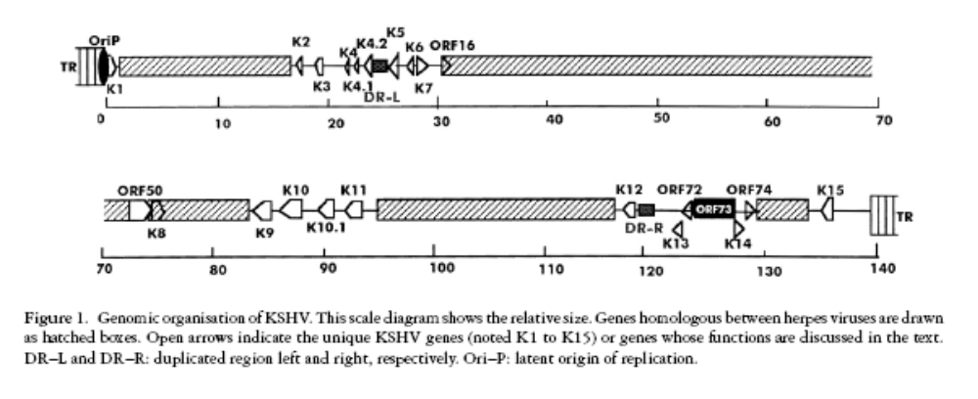

From Gruffat et al. 2000 (This figure doesn’t indicate all the ORF areas)

